Why use custom exceptions?

Java exceptions cover almost all the general type of exceptions that may occur in the programming. However, we sometimes need to create custom exceptions.

Following are few of the reasons to use custom exceptions:

* To catch and provide specific treatment to a subset of existing Java exceptions.
* Business logic exceptions: These are the exceptions related to business logic and workflow. It is useful for the application users or the developers to understand the exact problem.

In order to create custom exception, we need to extend Exception class that belongs to java.lang package.

1. // class representing custom exception
2. **class** InvalidAgeException  **extends** Exception
3. {
4. **public** InvalidAgeException (String str)
5. {
6. // calling the constructor of parent Exception
7. **super**(str);
8. }
9. }
11. // class that uses custom exception InvalidAgeException
12. **public** **class** TestCustomException1
13. {
15. // method to check the age
16. **static** **void** validate (**int** age) **throws** InvalidAgeException{
17. **if**(age < 18){
19. // throw an object of user defined exception
20. **throw** **new** InvalidAgeException("age is not valid to vote");
21. }
22. **else** {
23. System.out.println("welcome to vote");
24. }
25. }
27. // main method
28. **public** **static** **void** main(String args[])
29. {
30. **try**
31. {
32. // calling the method
33. validate(13);
34. }
35. **catch** (InvalidAgeException ex)
36. {
37. System.out.println("Caught the exception");
39. // printing the message from InvalidAgeException object
40. System.out.println("Exception occured: " + ex);
41. }
43. System.out.println("rest of the code...");
44. }
45. }

**Output:**

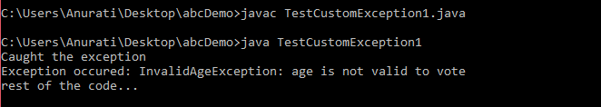

### **Example 2:**

**TestCustomException2.java**

1. // class representing custom exception
2. **class** MyCustomException **extends** Exception
3. {
5. }
7. // class that uses custom exception MyCustomException
8. **public** **class** TestCustomException2
9. {
10. // main method
11. **public** **static** **void** main(String args[])
12. {
13. **try**
14. {
15. // throw an object of user defined exception
16. **throw** **new** MyCustomException();
17. }
18. **catch** (MyCustomException ex)
19. {
20. System.out.println("Caught the exception");
21. System.out.println(ex.getMessage());
22. }
24. System.out.println("rest of the code...");
25. }
26. }

**Output:**

